ADX FT8 Pocket Construction Notes: March 2023

This document is written to help you complete Barb’s FT8 Pocket project board shown below:

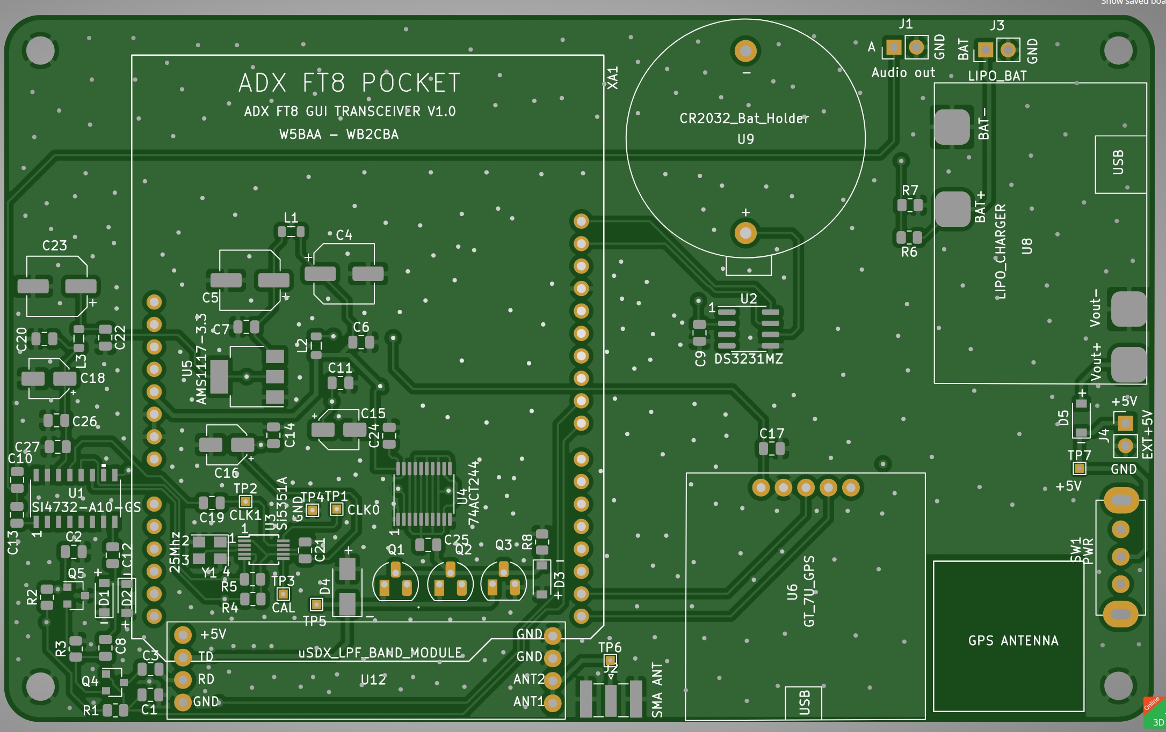

This board is a derivative of the ADX Transceivers developed by Barb, Wb2CBA;
https://github.com/WB2CBA/ADX
Here is the schematic for the project:

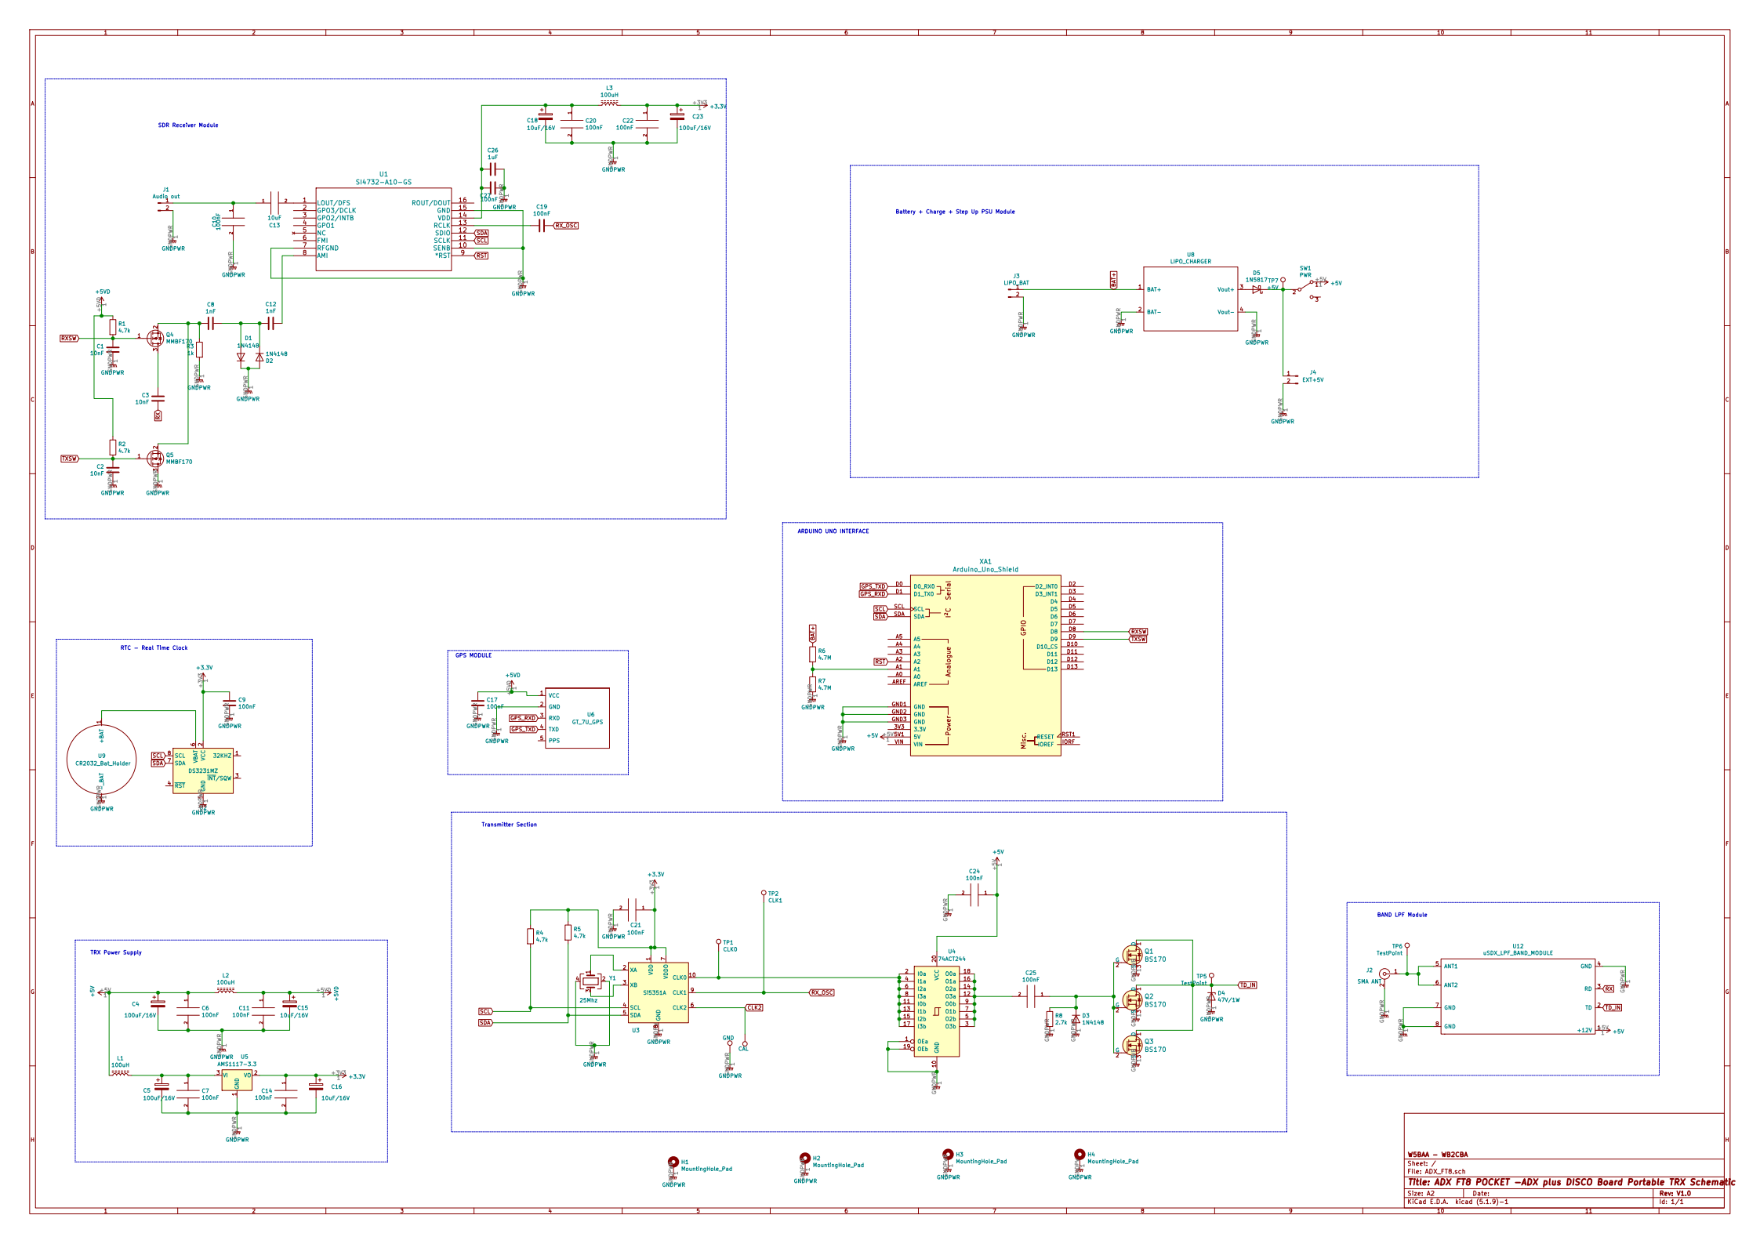

Here are photos of a fully populated board,

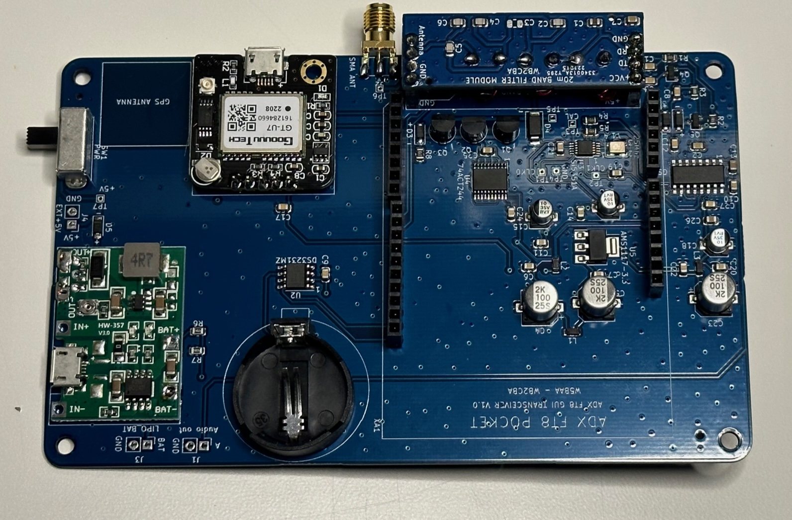

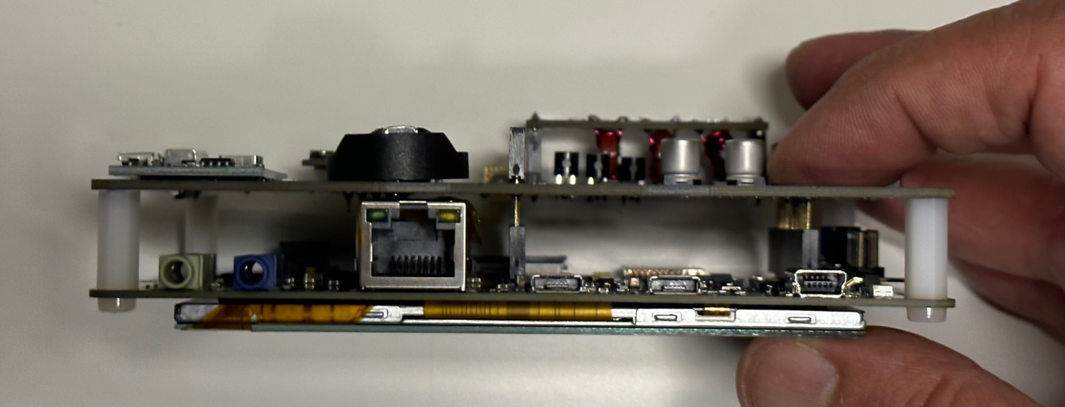

User Installed Items

The board requires that you install the following items.

1) Si4732 Chip

2) Three BS170’s

3) SMA Female RF Connector

4 Coin Cell Battery for Real Time Clock (RTC) Operation

5) GPS Receiver for Setting RTC Date and Time

https://www.amazon.com/Navigation-Satellite-Compatible-Microcontroller-Geekstory/dp/B07PRGBLX7?th=1

5) Lipo battery

https://www.amazon.com/dp/B07TWHGCB3?cafId=7514dc88-bf4f-437d-8ccb-7f4407beeab0&cafASIN=B07TWHGCB3&ref_=cm_sw_r_apin_dp_ZBAXY71REPAP0B6GSD88

6) Battery Management Module

https://makerselectronics.com/product/adjustable-step-up-18650-li-ion-battery-charger-discharge-hw-357-3-7v-9v-5v

Before you install the board please energize using the USB port. Then, monitor the output voltage at OUT+ and OUT- and adjust the output voltage using the pot to about 5.2 volts.
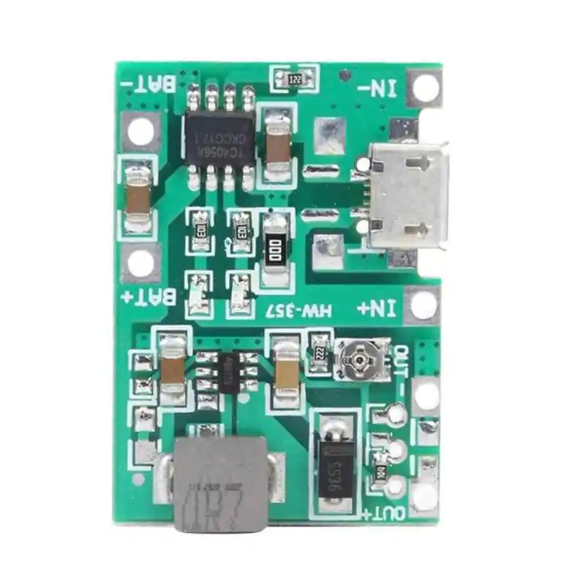
7) Mono Audio Connection

In addition to the Ardunio Header Connectors a mono channel Audio Connection is required between the project board and the STM32F746 Disco Board. Shown below are photos showing how I made the Audio Connection to the Line In Phone plug on the 746 Board.

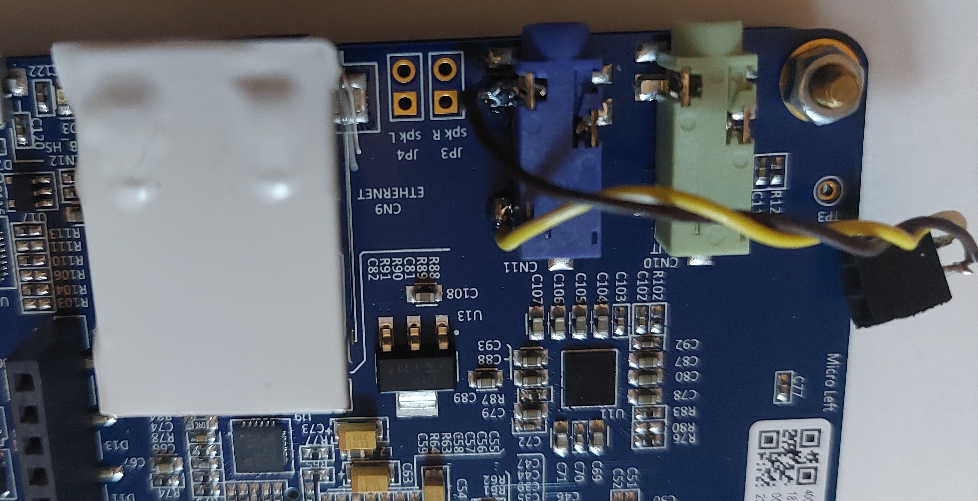
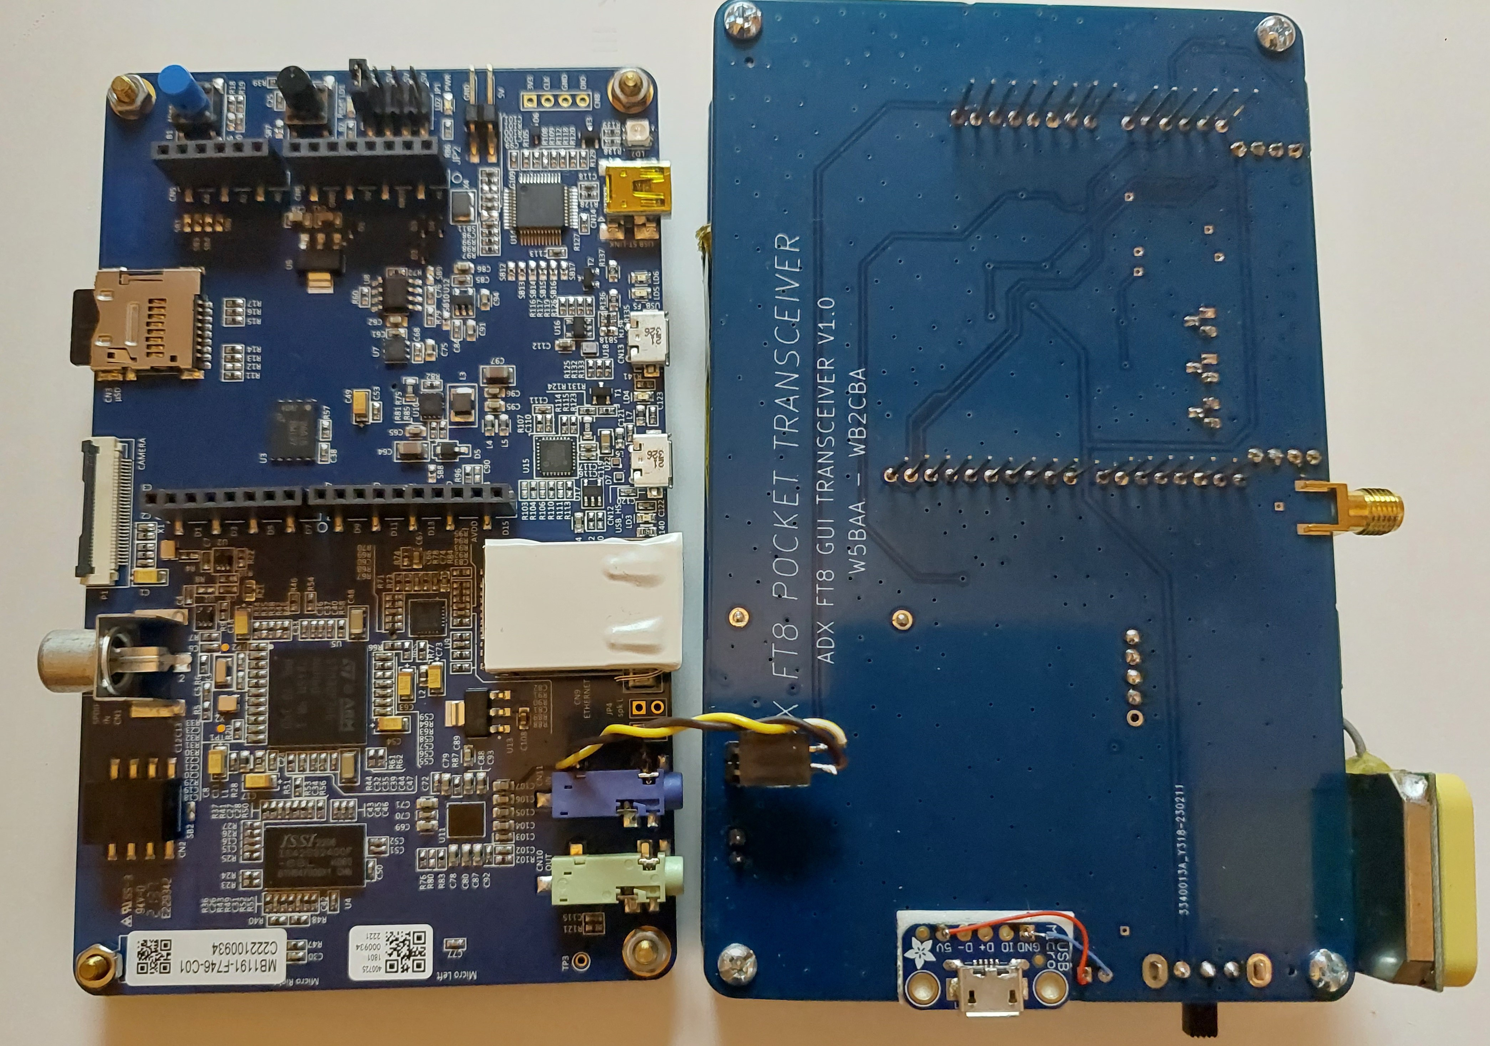
8) Power Connections

And, here is how I made the power connections.

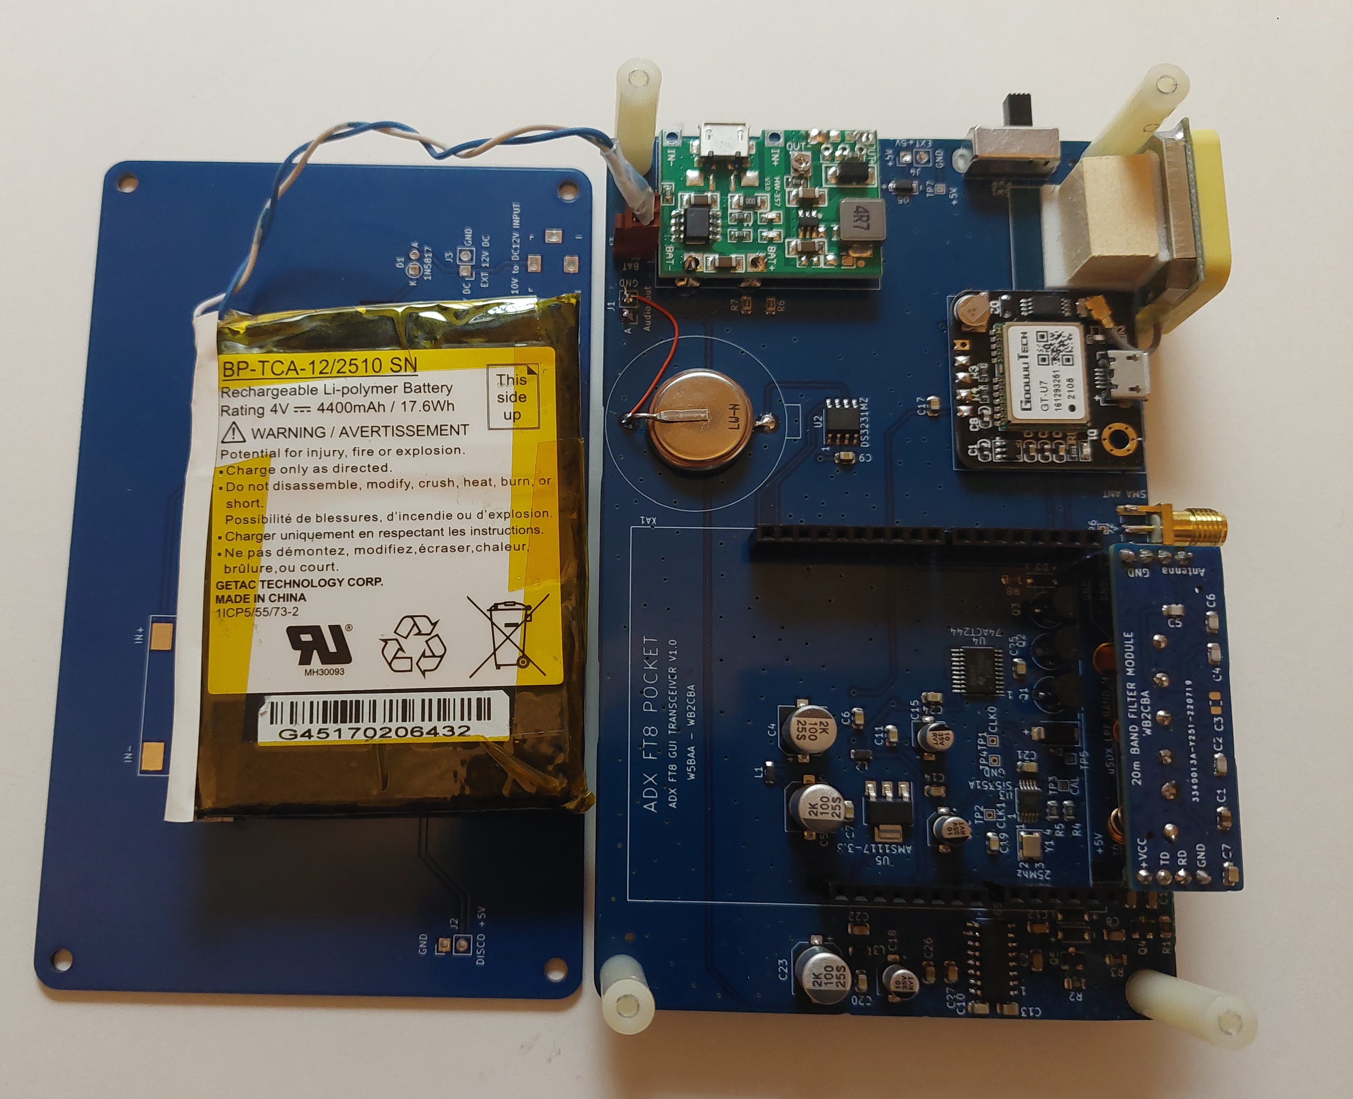

Some Bright Spark may note the red wire connected to the RTC battery. You need not install such a wire. This wire was installed to correct the ONE and ONLY FLAW in the PCB Fabrication.
This error has been corrected in the project fabrication files
9) Dire Warnings

I found that you may power the entire unit using the USB port on the Battery Management Board without a lithium battery installed on the boards. This works well except I find the Battery Management Board gets really hot.

Both Barb and I have installed lithium batteries and we are getting really great battery life. Barb installed a 5000 mahr battery and I am using a 4000 mahr battery.

If you do elect to power the unit directly from a 5 volt power supply without battery I suggest that you use the EXT +5V terminals next to the power switch.

There is the potential of shorting between the project board and the RJ45 Ethernet Connector on the Disco board. It is recommended that a layer of plastic tape be applied to the top of the RJ45 connector as illustrated in the photo above.

